Stop Motion 11/5
Stock photo or video- means someone else took the picture or video and you pay to use it or it is available for free.
Talked about inspirations, how to come up with ideas for projects.
Lego is a good medium to start in stop motion with. You have control of their movements.
Talking about creative inspirations is a good way to motivate to do creativity. One of the goals of this club is to help motivate people to explore ways to be creative.
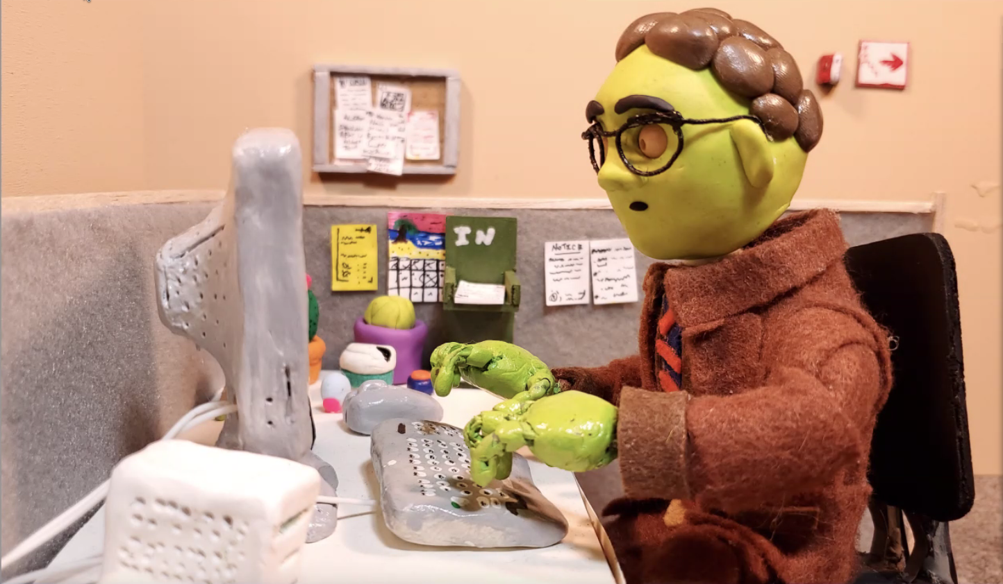
Master shot or Medium shot- meaning it is wide enough to have all the important visuals in . Safe shot to switch back to.
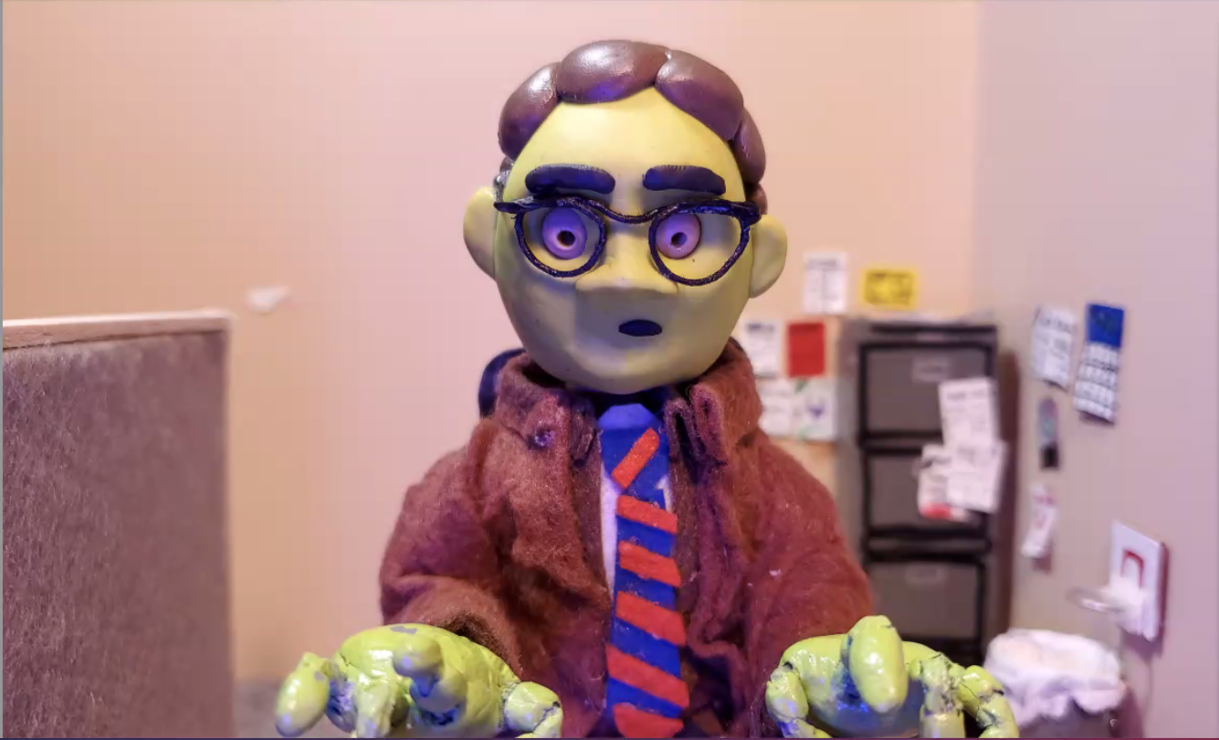
Close -up shot. Because of the master shot you understand this character is looking at a computer. Note the blue light glow in the eyes from a computer screen. Keeps the continuity between images. Blue glow produced by adding a “gel” possibly blue paper in front of a light.
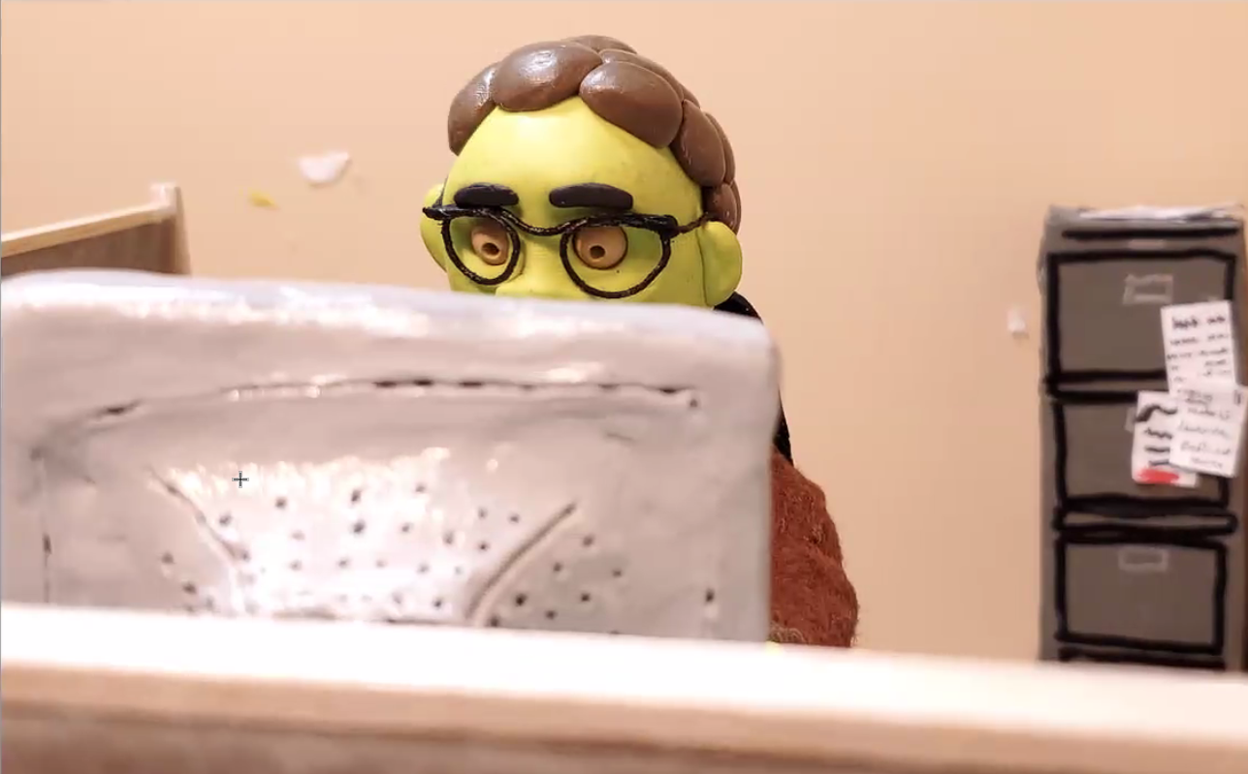Image to portray the dullness in an office.
Next month talking about lighting. Please bring work to share if you want. Homework: bring a photo that shows lighting or camera angles that express an emotion visually.

