Stop Motion 2/4/23
Share work from assignments
Topic for the day- Paper Cut Outs
Make sure your background layer is fixed in place. Consider a light adhesive like tape or clay to keep moving parts in position for photos. Consider using a tool to move pieces of paper around, fingers can be clumsy. Example pencil, tweezers, or paper clip.
When creating a paper puppet- try to find a way to make joints move with a connection point- maybe thread.
Tips or interesting creative choices
Create sense of depth by adding shadow. Also putting object in front and behind like the creature in the waves.
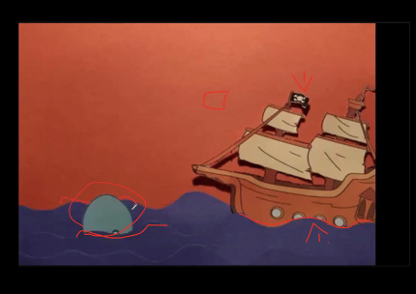
Hinges in frog puppet hidden well below, busy design of frog skin helps. Also, background looks rich, but primarily black. Simplicity can help create a beautiful image.
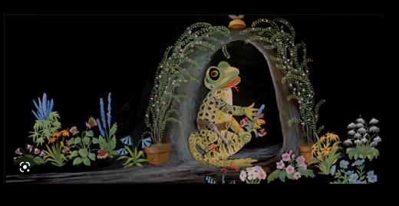
Evelyn Lambert film link: Mr Frog Movie
Assignment: Create a 10 sec papercut out film. 10 sec not including title cards, but please include title cards.
