Stop Motion 3/4/23
Introductions and share experience.
Share work assignments
Brick films/Lego Stop Motion main topic
History- first Brickfilm 1973 Journey to the Moon- no found copies, just images.
Tips for good work:
Background/Set: use a firm solid table top, anchored incase of elbow bump, dog. Add something for the background- black tee shirt stretched out to represent space, green paper to add background later. Create a sense of environment.
Watch your lighting- pay attention to the shadows. You want definition and contrast with the shadows, but still to clearly see action. Ways to add more lights, flashlights, add white sheet to bounce light back.
Ease in and out with movements: 12 frames per second - meaning 12 photos per second. Easing in and out means having more frames of animation at the beginning and end of the movements, less in the middle.
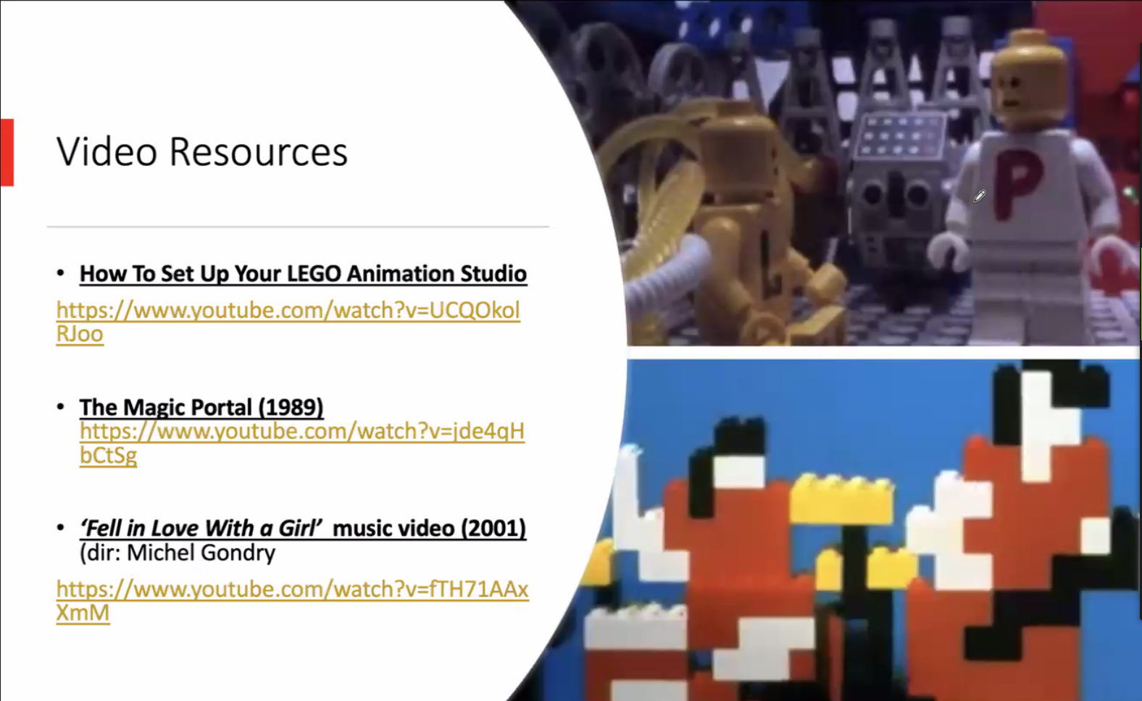
Assignment for April, 2023
Make a Lego Brickfilm
Incorporate the color green in someway- Cole’s favorite color and it’s Spring
Have the video run at least 10 sec
Incorporate at least 3 sound effects
No Legos? Here is an alternate assignment. 10 sec of stop motion with green included.

